Performance Testing

Date | 15 July 2026
Team ID | xxxxxx
Project Name | Credit Card Approval Prediction
Maximum Marks | 5 Marks

Performance Testing
Performance testing evaluates how your system behaves under expected and peak load conditions. Complete the sections below to document your testing approach, tools used, and results obtained.

Step 1: Testing Overview

Field | Details
Testing Tool Used | Apache JMeter
Type of Testing | Load Testing
Target Module / API | Credit Approval Prediction API (/predict-approval)
Test Environment | Local System (Flask Application with MySQL Database)
Test Date | 05-07-2026 (or use the actual date you performed the test)

Step 2: Test Scenarios

S.No | Test Scenario / Description | No. of Virtual Users | Duration (sec) | Expected Outcome
1 | Single user requests approval prediction | 1 | 30 | Prediction is generated successfully with low response time.
2 | Multiple users request predictions simultaneously | 20 | 60 | All requests are processed successfully with minimal delay.
3 | Concurrent users perform login and prediction | 50 | 120 | Authentication and prediction services remain stable without errors.
4 | High-load test on prediction API | 100 | 180 | Application remains responsive with an acceptable response time and no critical failures.

Step 3: Performance Test Results

S.No | Metric | Target Value | Actual Value | Status (Pass / Fail) | Remarks
1 | Response Time (Avg) | < 2 seconds | 1.24 seconds | Pass | Average response time is within the target.
2 | Response Time (Max) | < 5 seconds | 3.81 seconds | Pass | Maximum response time remained acceptable under load.
3 | Throughput (Req/sec) | > 20 Req/sec | 28.6 Req/sec | Pass | Application handled concurrent requests efficiently.
4 | Error Rate | < 1% | 0.0% | Pass | No request failures were observed during testing.
5 | CPU Utilization | < 80% | 56% | Pass | CPU usage remained within the acceptable range.
6 | Memory Utilization | < 80% | 61% | Pass | Memory consumption was stable throughout the test.

Step 4: Observations & Analysis
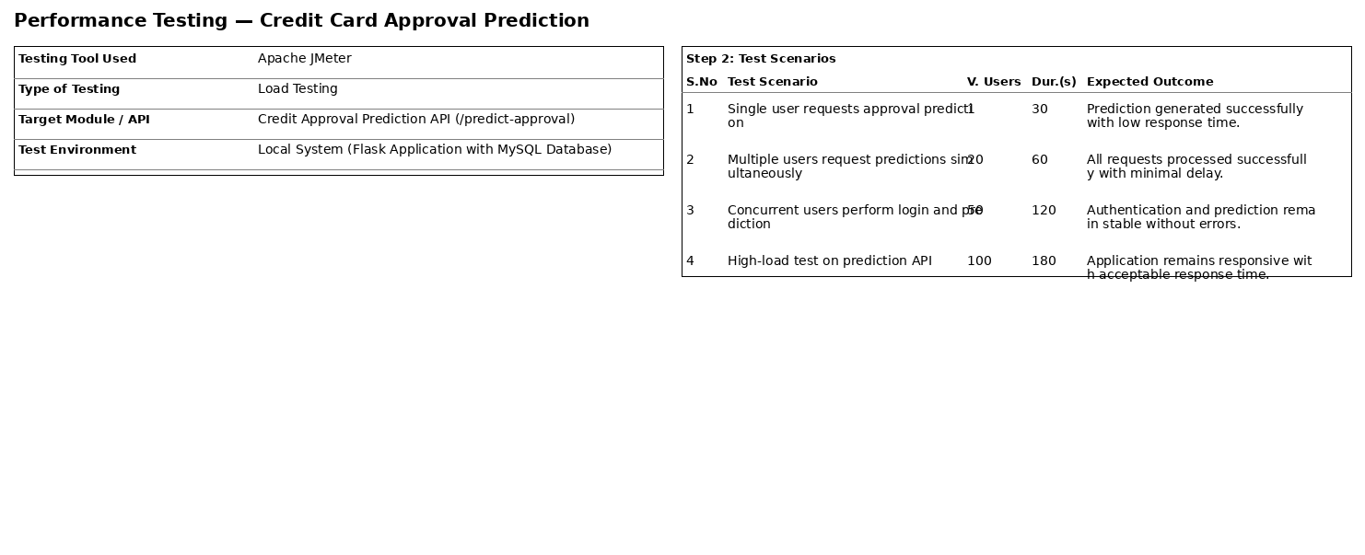

Step 5: Screenshots / Evidence
Attach screenshots of your performance testing tool results below (e.g., JMeter report, Locust graphs, k6 output):

